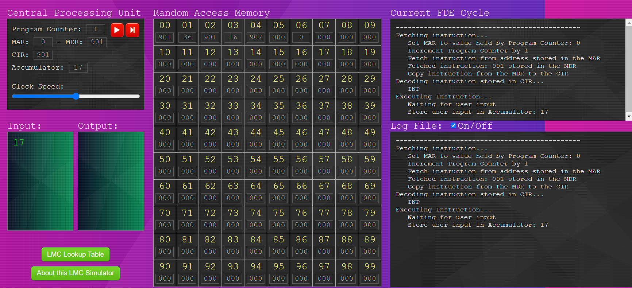

**Fetching instruction...  
   Set MAR to value held by Program Counter: 0  
   Increment Program Counter by 1  
   Fetch instruction from address stored in the MAR  
   Fetched instruction: 901 stored in the MDR  
   Copy instruction from the MDR to the CIR  
Decoding instruction stored in CIR...  
   INP  
Executing Instruction...  
   Waiting for user input  
   Store user input in Accumulator: 17**

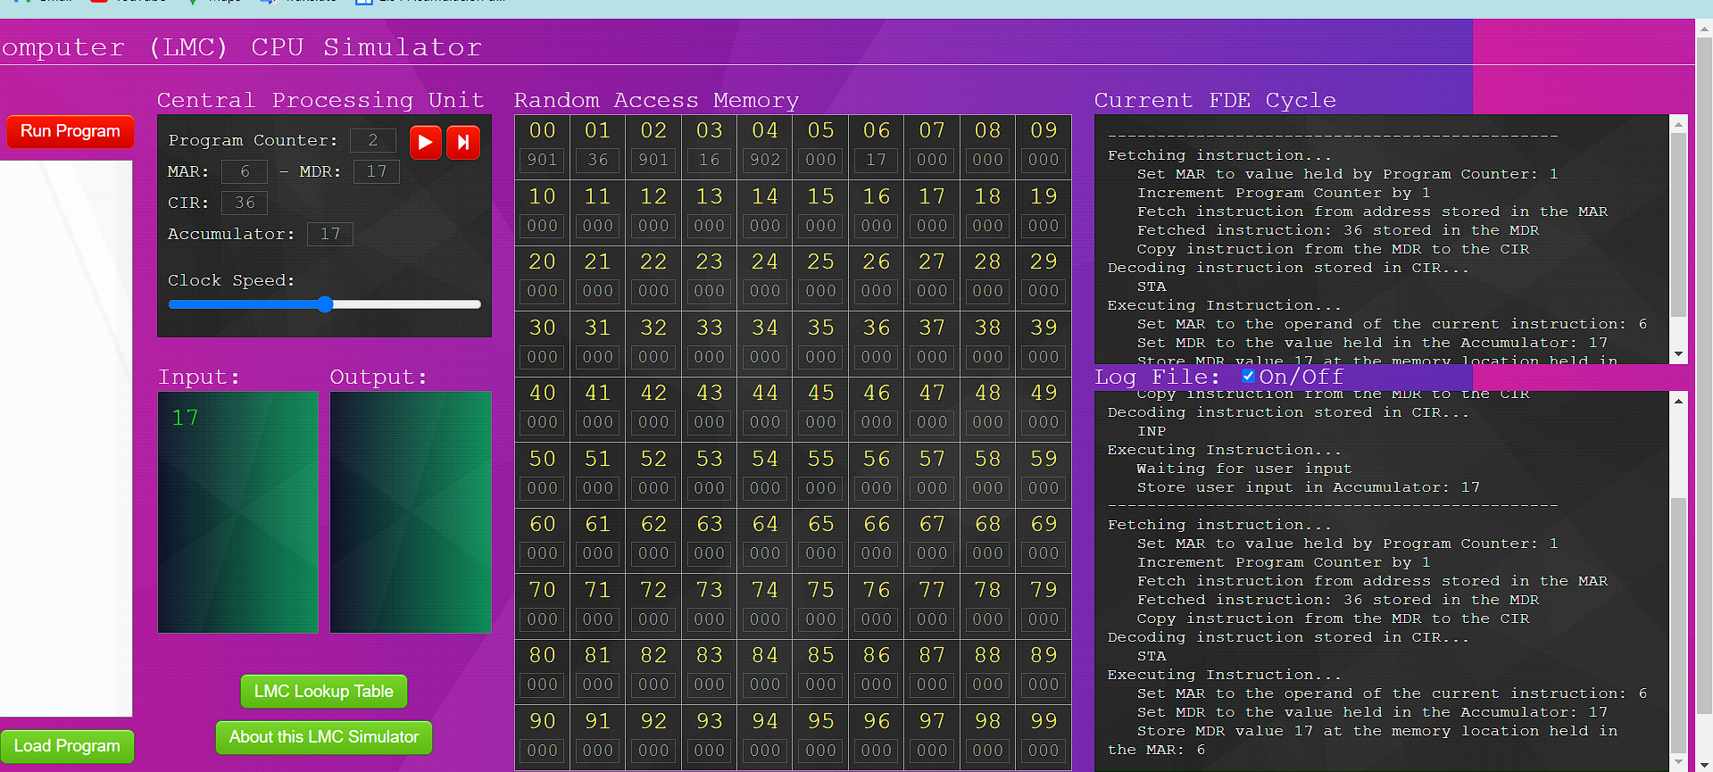

**Fetching instruction...  
   Set MAR to value held by Program Counter: 1  
   Increment Program Counter by 1  
   Fetch instruction from address stored in the MAR  
   Fetched instruction: 36 stored in the MDR  
   Copy instruction from the MDR to the CIR  
Decoding instruction stored in CIR...  
   STA  
Executing Instruction...  
   Set MAR to the operand of the current instruction: 6  
   Set MDR to the value held in the Accumulator: 17  
   Store MDR value 17 at the memory location held in the MAR: 6**

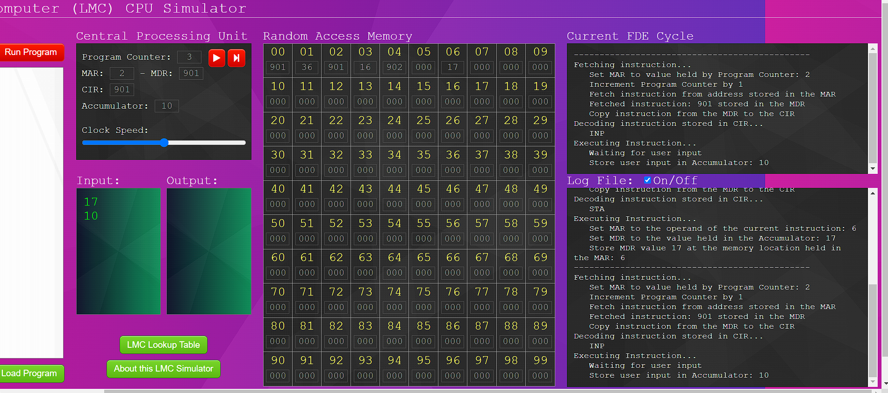

**Fetching instruction...  
   Set MAR to value held by Program Counter: 2  
   Increment Program Counter by 1  
   Fetch instruction from address stored in the MAR  
   Fetched instruction: 901 stored in the MDR  
   Copy instruction from the MDR to the CIR  
Decoding instruction stored in CIR...  
   INP  
Executing Instruction...  
   Waiting for user input  
   Store user input in Accumulator: 10**

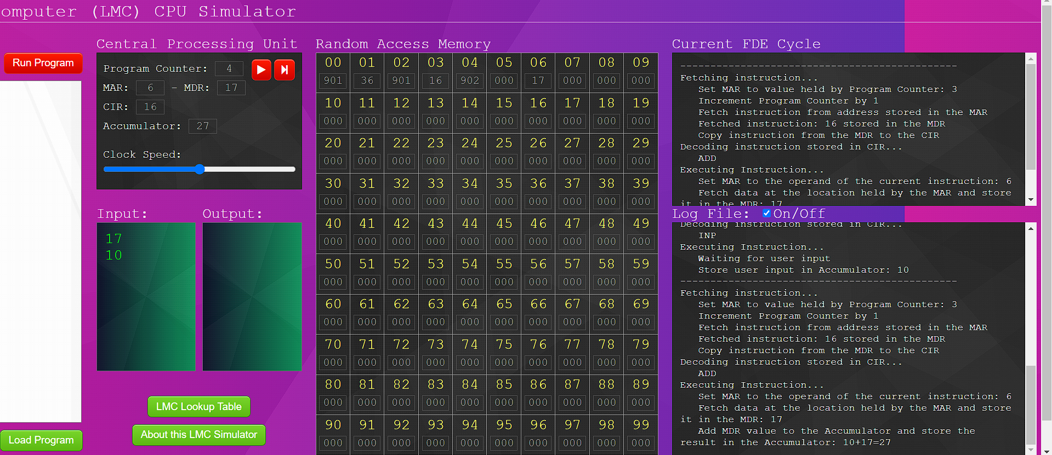

**Fetching instruction...  
   Set MAR to value held by Program Counter: 3  
   Increment Program Counter by 1  
   Fetch instruction from address stored in the MAR  
   Fetched instruction: 16 stored in the MDR  
   Copy instruction from the MDR to the CIR  
Decoding instruction stored in CIR...  
   ADD  
Executing Instruction...  
   Set MAR to the operand of the current instruction: 6  
   Fetch data at the location held by the MAR and store it in the MDR: 17  
   Add MDR value to the Accumulator and store the result in the Accumulator: 10+17=27**

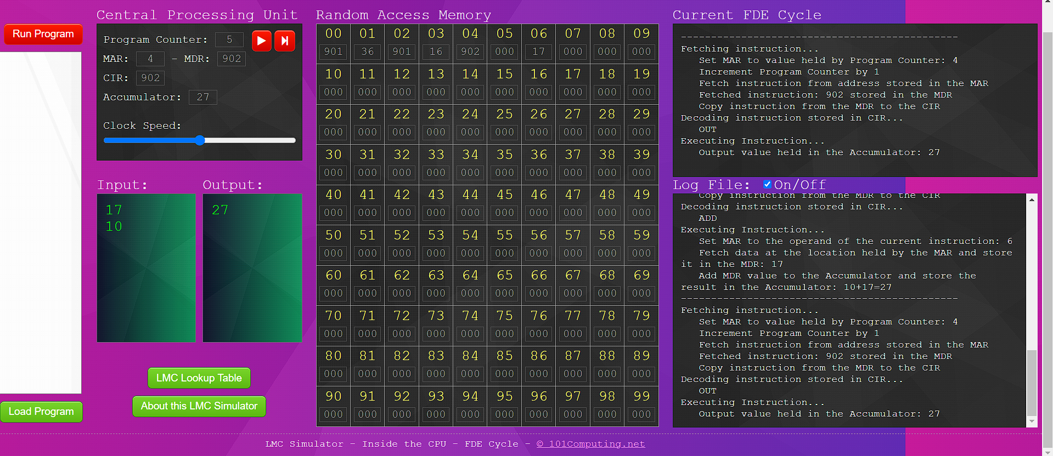

**Fetching instruction...  
   Set MAR to value held by Program Counter: 4  
   Increment Program Counter by 1  
   Fetch instruction from address stored in the MAR  
   Fetched instruction: 902 stored in the MDR  
   Copy instruction from the MDR to the CIR  
Decoding instruction stored in CIR...  
   OUT  
Executing Instruction...  
   Output value held in the Accumulator: 27**

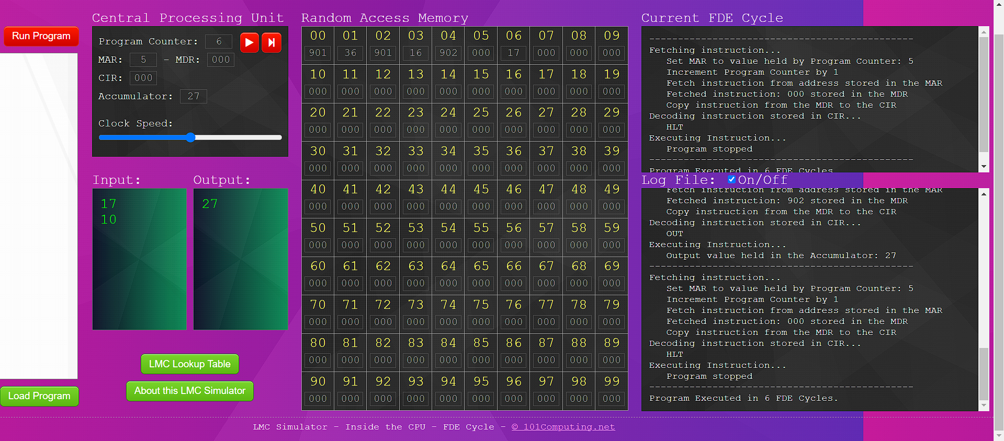

**Fetching instruction...  
   Set MAR to value held by Program Counter: 5  
   Increment Program Counter by 1  
   Fetch instruction from address stored in the MAR  
   Fetched instruction: 000 stored in the MDR  
   Copy instruction from the MDR to the CIR  
Decoding instruction stored in CIR...  
   HLT  
Executing Instruction...  
   Program stopped  
----------------------------------------------  
Program Executed in 6 FDE Cycles.**